Flat Is Where It Is At

One of the biggest struggles I see on a daily basis is that players struggle with accuracy. Whether you miss shots to the left or right, or worse left and right, there is one main flaw that occurs…the club face is open or closed as they return to impact. This can lead to missing greens and putting too much pressure on the short game.

So what is the key to improving your accuracy and hitting more greens in regulation? You need to understand what your club face is doing at the top of the backswing. Since the back of the left hand mirrors the club face…”Flat Is Where It Is At”. You need to maintain a flat left wrist.

If you bow the wrist (A), like Dustin Johnson, your face will be closed as you return to impact resulting in a miss to the left. The opposite occurs if you have a cup in the wrist (B). The face will be open leading to a miss to the right.

- (B)

There are several training aids on the market that can teach you how to maintain a flat wrist, but I prefer drills that everybody can do. One of my favorites is a “Cross-Handed Backswing”. I came up with this in college after playing with a teammate who actually swung cross-handed. While mimicking his grip one day, I realized just how flat my left wrist stayed as swung to the top of my backswing.

Here is how the drill works (right handed golfer):
1. Place your left hand below your right hand on the grip
2. Take your normal address position
3. Make a full shoulder turn to the top of the backswing

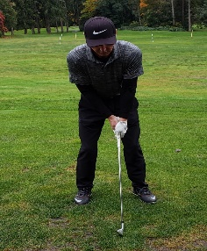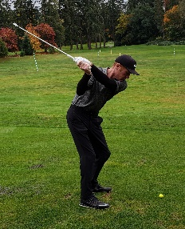

While I do not recommend hitting balls this way, I have seen players such as Ricky Fowler and Brookes Koepka actually do it. Typically I try to get students to just get the feeling of what the wrist is doing at the top. By learning how a flat left feels they are then able to try to duplicate that sensation in there full swing.

For help with learning that “Flat Is Where It Is At” or any other area of your game please visit www.brianflugstad.com to book your next lesson!

